Faculty Profile

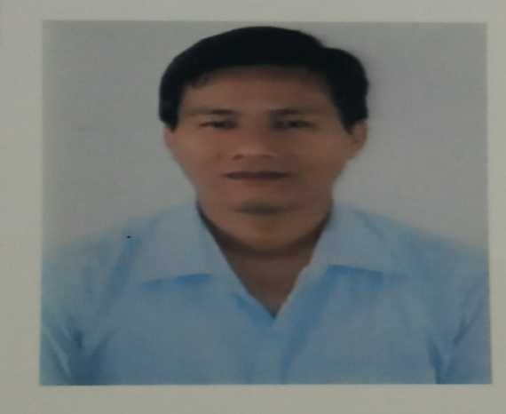

Name: :SANTOSH TAMANG
Designation: :ASSISTANT PROFESSOR
Address(College) : SOUTH MALDA COLLEGE, P.O. PUBARUN,
DIST. MALDA PIN 732215, WEST BENGAL
(Residence) `: VILL. CHAKKARMARI JOTE, P.O. BURAGANJ,
DIST. DARJEELING, PIN 734426, WEST BENGAL
Contact Mobile no. : 9800100423/8250488400
e-mail : santoshlopchan83@gmail.com
Teaching Areas :MICROECONOMICS, MACRO ECONOMICS
Research Interests : DEVELOPMENT ECONOMICS
Education :M.A., B ED.
Scholarship/Award/Fellowship etc.: N.A.
Professional Experience : N.A.
Teaching Experience : 02 years 2 months
Research : N.A.

ACADEMIC QYALIFICATIONS:
Examination Passed | Board/University | Subject/Area | Year of Passing | Division
Secondary Examinations | WBBSE | HIN,ENG,HIST,GEO,MATHS,LSC,PSC | 1999 | I
Higher Secondary | WBCHSE | HINA, ENGB, PHYS, CHEM, MATH, BIOS | 2001 | II
Bachelor’s | NBU | ECONOMICS, MATHS, STATISTICS | 2004 | II
Master’s Degree | NBU | ECONOMICS | 2006 | II
M. Phil | NA | NA | NA | NA
Ph.D. | NA | NA | NA | NA
B ED | IGNOU |  | 2014 | I

Research, Publications, and Academic Contributions:
A) Published Papers in Journals
Sl. No. | Title of the of the paper | Vol., No. and Page No. | Journal/Publisher | No. of  co-authors | Year of Publication | ISSN/ISBN No. | Impact Factor
 | N.A | N.A | N.A | N.A. | N.A. | N.A. | N.A.

B) (i) Articles / Chapters published in Books:
Sl. No. | Title with page nos. | Book Title, editor & publisher | ISSN/ISBN No.
 | N. A | N. A | N. A

(ii) Full Papers in Conference Proceedings:
Sl. No. | Title with page nos. | Details of Conference Publication | Year | ISSN/ISBN No.
 | N.A. | N.A. | N.A. | N.A.

(iii) Books Published as single author or as editor:
Sl. No. | Title with page nos. | Type of Book & Authorship | Publisher & ISSN/ISBN No.
NA | NA | NA | NA

C) Ongoing and Completed Research Projects and Consultancies
(i) Ongoing Projects / Consultancies:
Sl. No. | Title | Agency | Period
NA | NA | NA | NA

(ii) Completed Projects / Consultancies:
Sl. No. | Title | Agency | Period
NA | NA | NA | NA

(D) Research Guidance
Sl. No. | Number Enrolled | Thesis Submitted | Degree Awarded
M. Phil or equivalent | NA | NA | NA
Ph.D. or equivalent | NA | NA | NA

(E) (i) Training Courses, Teaching-Learning-Evaluation Technology Programmes, Faculty Development Programmes:
Courses Attended | Duration | Year | Academic Staff College/RCC | Name of the  University | Remark (project)
NA | NA | NA | NA | NA | NA

(ii) Papers presented in Conferences, Seminars, Workshops, Symposia
Sl. No. | Title of the Paper presented | Title of Conference / Seminar | Organized by | Whether international / national / state / regional / college or university level | Period
1 | Globalization and Human Development in India | Challenges to Indian Polity: Concept and Issues | Department. Of Politics, University of Gour Banga | International | 20th-21st July, 2017
2 | Role of MGNREGA in Rural Development of Phansidewa Block, WB | Rural Development in India: Contemporary Reflection | Centre fo Studies in Decentralization and Rural Reconstruction, Rabindra Bharati University | International | 26th-27th April, 2018

(iii) Invited Lectures and Chairmanships at national or international conference / seminar etc.
Sl. No. | Title of Lecture / Academic Session | Title of Conference / Seminar etc | Organized by | Whether international / national | Duration (Dates)
 | NA | NA | NA | NA | NA

(iv) Participation in Conferences/ seminars etc
Sl. No. | Title of Conference / Seminar / Workshop | Organized by | Funding Agency | Duration | Level
 | N.A. | N.A. | N.A. | N.A. | N.A.

(v) Any other achievement and roles played actively:

a) National/State Level Tests Qualified:
SL No. | Name of the Test | Conducting Agency | Subject | Year | Remark
1 | NET | UGC | ECONOMICS | DECEMBER, 2013
2 | SET | WBCSC | ECONOMICS | DECEMBER, 2013

b) Member of U. G. Board of Studies in Geography:

SL No. | Position | Name of Board | Subject / Discipline | University | Year
1 | NA | NA | NA | NA | NA
(c) Short Term Courses:

SL No. | Name of the course | Title | Institution | Duration | Period | Remark
1 | RESEARCH WORKSHOP | RESEARCH METHODOLOGY IN ENVIRONMENTAL ECONOMICS | VISVA-BHARATI | 7 DAYS | 16TH-22ND NOVEMBER, 2018

(d) Membership of Professional Organizations:

SL. No. | Name of Professional Body | Affiliation/Location | Type of membership | Number of membership | Membership Since
1
2

(e) Acted as Reviewer of Journals: NIL

f) Conferences / seminars / Workshop / Symposium organized:

SL No | Seminar/Workshop/Conference/Symposium etc. | Date(s) | No. of participants | Key speakers
NA | NA | NA | NA | NA

ADMINISTRATIVE RESPONSIBILITIES: N.A.

PARTICIPATION IN COLLEGE ADMINISTRATION: N.A.

Member or Convener of various committees (last five years):

Sl. No. | Name of the Committee | Member/Convener | Year | Remarks
1. | ADMISSION COMMITTEE | MEMBER | 208-19
2. | SPORTS COMMITTEE | MEMBER | 2018-19
3. | CINE-CLUB | MEMBER | 2018-19

I do, hereby, declare that the information provided is correct and authentic to the best of my knowledge and belief. I will be held responsible for any misleading and incorrect information, if any.
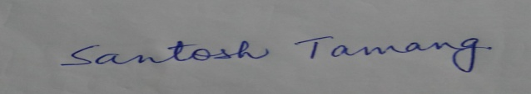
Date: Signature

